Software Requirements Specification

for

Virtual Personal Assistant

**Version 1.0 approved**

**Prepared by 20CE041, 20CE043**

**CSPIT-CE**

**27-01-22**

1. **TABLE OF CONTENTS**

1. **Introduction 3**
   1. Project Introduction 3
   2. References 4
2. **Overall Description 4**
   1. Product Perspective 4
   2. Product Features 5
   3. Operating Environment 7
   4. Assumption And Dependencies 7
3. **System Features 8**
   1. Functional Requirements 8
4. **Other Nonfunctional Requirements 9**
   1. Performance Requirements 9
   2. Software Quality Attributes 9
5. **Revision History**

|  |  |  |  |
| --- | --- | --- | --- |
| **Name** | **Date** | **Reason For Changes** | **Version** |
|  |  |  |  |
|  |  |  |  |

# Introduction

**1.1 project introduction**

## Artificial Intelligence is a technique of getting machines to work and behave like humans. For example healthcare, marketing, business analytics, robotics, etc. The concept of Artificial Intelligence was discovered by John McCarthy. Artificial intelligence refers to systems or machines that mimic human intelligence to perform tasks and can iteratively improve themselves based on the information they collect. AI manifests in several forms. A few examples are:

Chatbots use AI to understand customer problems faster and provide more efficient answers

Intelligent assistants use AI to parse critical information from large free-text datasets to improve scheduling

Recommendation engines can provide automated recommendations for TV shows or on social media recommend the short videos according to our viewing habits

AI is much more about the process and the capability for superpowered thinking and data analysis than it is about any particular format or function. Although AI brings up images of high-functioning, human-like robots taking over the world, AI isn’t intended to replace humans. It’s intended to significantly enhance human capabilities and contributions. That makes it a very valuable business asset.

Features of Artificial Intelligence are as follows:

* Object detection
* Natural processing language
* Robotics

There are various types of Artificial Intelligence such as:

* Artificial narrow intelligence
* Artificial general intelligence
* Artificial superintelligence

Alexa, face verification, autopilot feature at the pilot, social human at Sophia, Google maps are some of the examples of Artificial Narrow Intelligence. Google Eye Doctor by Google, Recommendation system in the search engines are some of the applications of Artificial Narrow Intelligence.

In today’s generation, 38% of people are using virtual assistants which are built with the concept of Artificial Intelligence.

Our project is also based on a virtual assistant like Alexa or Siri that is under artificial narrow intelligence but our project is in a very basic AI concept. this project help to understand the algorithms and working process that how can this type of virtual assistant work

**1.2 References**

Reference has been taken from some popular assistants like Alexa, Siri, etc.

Reference has also been taken from the AI Assistant builder tutorial from Google and YouTube

Reference Links(Only for References):

<https://www.udemy.com/course/learn-to-create-advance-ai-assistant-jarvis-20with-python/>

https://www.udemy.com/course/jarvis-ai/

Reference Articles:

<https://www.sciencedirect.com/science/article/pii/S0969698920312911>

<https://files.eric.ed.gov/fulltext/EJ1267812.pdf>

# Overall Description

# 2.1 Product Perspective

The main goal to build this project is to work smartly and save time for typing and searching on our own. It can take notes also so it makes our work easier and remember our important thing and meeting and remind us.

J.A.R.V.I.S is a standalone personal AI assistant that listens to your voice using Google’s Speech API and uses AI-generated speech to respond to your requests. Below are some other features of JARVIS -

- automate tasks like opening apps, searching on browsers like Google and Firefox, opening and editing files, writing emails, telling the time, sending email, setting reminders finding a location of your choice, etc. on your computer

- Give daily reports of your computer usage, internet usage, app usage, amount of time sitting down and can even give recommendations based on this data. An example would be - ‘you have been sitting on your computer for over an hour, go outside and take a break!’.

- allows you to schedule tasks to be done at a specific time. JARVIS will even remind you of certain tasks that need completing as those deadlines approach, making sure you don’t be late for anything! It can also go to offline mode whenever you require to close the application.

**2.2 Product features**

our assistant has the following features:

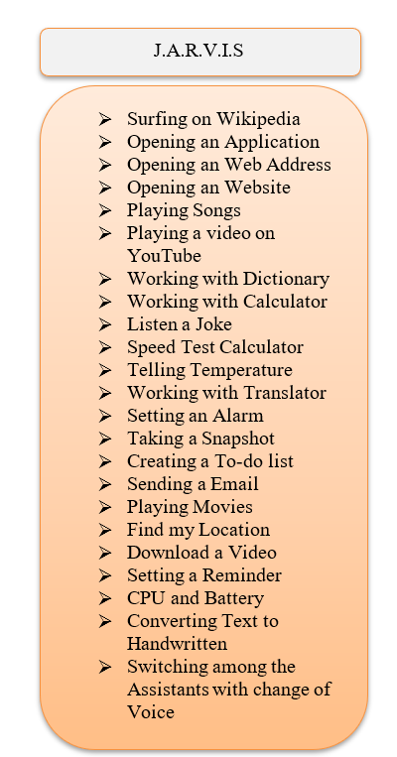

* **Searching summary on Wikipedia:**

If we want to search on Wikipedia and get a summary of something or place or some person, we can ask our ‘JARVIS’, it tells summary on whatever we ask

* **Open application / close application:**

It can open the application as we commanded and once we did our work it can close it

* **Open any web address:**

If we want to open some web address we can command to our ‘JARVIS’ it can open it for us

* **Open any website :**

Likewise opening web address features, can open any website

* **Play any song:**

It can open any song that you have downloaded. If you ask for a song and it’s not available on your pc it plays a song on YouTube

* **Play any videos on YouTube:**

It can open any video that you ask for

* **Search engine:**

You can search for anything on google by just asking

* **Telling joke:**

We ask to tell a joke and it tells us a joke that he found

* **YouTube automation:**

It can do YouTube control actions like play, pause, forward 10 sec, backward 10sec, restart, mute, full screen, next video, previous video, turn on/off caption, etc

* **Chrome automation:**

it can do chrome control actions like open new tab, close tab, open new window, open incognito mode, show history, show downloads, open task manager, clear brow history, help center, make a bookmark, reopen last 10 tabs that you closed earlier

* **Taking a screenshot:**

It can take and screenshot and save it wherever you ask and it also asks for the name of the screenshot

* **Changing speech rate:**

If with have to read something and the speed is not comfortable we can change it

* **My word repetition:**

If we have to repeat our word we can do

## 2.3 Operating Environment

The operating environment for our assistant is as listed below.

Operating system: Windows

platform: python and AL base concept

## 2.4 Assumptions and Dependencies

The main assumption of this project is to try to make the user’s life easier and reduce the no efforts to do certain tasks by only giving a voice command it depends on the user’s need and interest but it’s perfectly trying designed to be useful.

# 3 System Features

**3.1** **Functional Requirements**

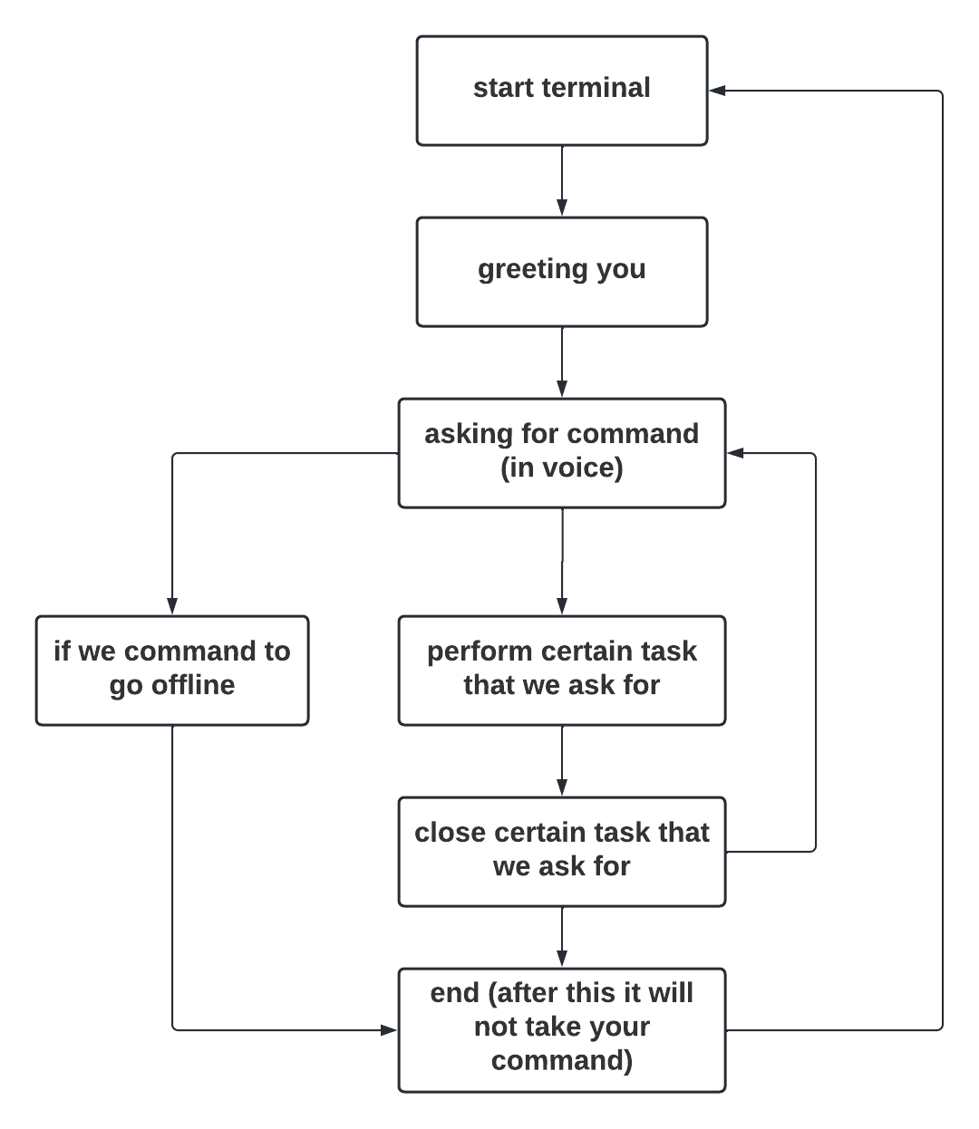

As we can see in this flowchart this voice assistant work like first when you run the assistant in terminal first it will greet you according to the time and then it asks for command by saying it. It takes our command as in voice command then it goes speech recognition module and figures out what we said now it goes to other modules according to our command like for example if we have to convert text into a speech there is a module named pyttsx3 if we want to know something’s Wikipedia there is a module for that is Wikipedia and for to take a screenshot there is a module named pyautogui etc. then is will close certain apps or website that we commanded in this whole situation it continuously takes our command after we command it to go offline or you need a break it will terminate and stop taking our command

**4 Other Nonfunctional Requirements**

## 4.1 performance requirement

As per this project on this bases for performing or running this assistant you have to have vs code and import certain and necessary python modules and there are more functions of surfing and searching functions so to run properly you have to check that you have proper wi-fi

## 4.2 Software Quality Attributes

* **AVAILABILITY:** our assistant is available 24*7 you can access it time and how much time you want to run
* **CORRECTNESS:** it is 90% give you the correct output that you ask for but it has some hearing issues right now
* **USABILITY:** it is the frequently useable assistant

# Other Requirements

**Appendix C: Issues List**

* Hearing issues